NEWS –

Scodix unveils Smart High-Definition technology at Printing United

New Scodix Ultra 6000 powered by SHD Press is engineered to deliver embellishment and economic benefits for the packaging and graphics market
SCODIX, ISRAEL – September 29, 2022 – Scodix, today announces the commercial launch of the next generation of its Ultra Digital Enhancement Press series, the Scodix Ultra 6000 powered by SHD (Smart High Definition). This breakthrough technology builds upon the success of the Scodix Ultra 6000 and is directly targeted at the packaging sector and high-definition printers, offering a new embellishment application as well as economic and sustainability benefits.
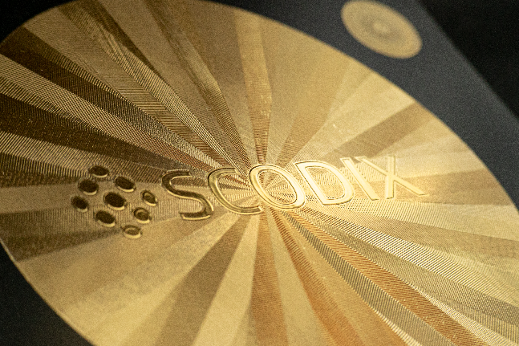
Scodix Smart High Definition is algorithm-controlled digital printing that achieves high accuracy and quality precision of complicated detailing for foiling and spot embellishments. The new press continues to enhance sheets up to B1/41-inch size and, like the Ultra 6000 press, offers economic advantages for versioning or customisation, and efficient production – with shorter overall time to market.
New Scodix Ultra 6000 powered by SHD Press is engineered to deliver embellishment and economic benefits for the packaging and graphics market

Smart High Definition gives the clarity and definition to foiling suitable for the beauty, healthcare, chocolate and spirits packaging markets. Scodix Foil™ is also enhanced by SHD with precision and accuracy to achieve fine delicate details in designs and in micro fonts, offering customers increased flexibility and greater choice as to how they create impact for their brand personas.
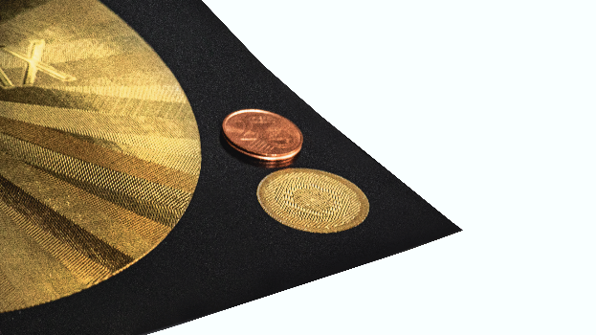
Eli Grinberg, CEO & Co-Founder at Scodix says, “Scodix is now fully positioned and prepared for taking on all the verticals for print, including packaging. We offer a range of ten different embellishing applications compatible with a wide range of paper stocks up to B1 format. SHD owners will have the production have the production economies, flexibility and quality to go beyond all existing processes.
Scodix Foil™ is also enhanced by SHD with precision and accuracy to achieve fine delicate details in designs and in micro fonts, offering customers increased flexibility and greater choice
“With a growing awareness of our impact on the planet, Scodix production offers benefits for sustainability benchmarking and eliminates the need to make dyes which can be etched with use of acids, wasted in litres of water - all impacting our natural resources. We take our role in this industry very seriously, so it is essential that we offer our customers all the benefits of increased production while not forgetting about our commitment to the environment.”

(ENDS)

About Scodix
Scodix Ltd. is a leading provider of industrial digital print enhancement presses, delivering stunning and luxurious decorative effects including Scodix Sense™ embossing, Scodix Foil™, Scodix Spot™ varnish, Scodix Cast&Cure™ holographic effects, Scodix Crystal™, Scodix Metallic™, Scodix Glitter™, Scodix Braille™ and customized embellishment with Scodix VDE™ variable data.
Scodix presses have been proven in the industry to increase economic opportunity for the printers and converters who use them, while enhancing productivity by replacing traditional analogue embellishment techniques. As a clean, green process with no VOC emissions, Scodix PolySense™ digital enhancement eliminates the need for plates, molds, chemicals, and solvents while reducing energy consumption.
The Scodix Ultra series delivers embellishments in the finest detail from A3 to B1 formats. Developed for the packaging sector, the Ultra 5000 and 6000 presses work with thicker substrates and incorporate industrial pallet feeders and stackers, with the flagship Ultra 6000 offering a larger B1 format, the largest currently available on the market and Smart High Definition (SHD) precision. The Scodix Ultra 3000 and Ultra 4000 presses both incorporate Scodix W2P software, with the Ultra 3000 tailored towards Web2Print and the Ultra 4000 supporting Web2Pack applications.

For more information, visit www.scodix.com or email info@scodix.com.

— ### —

Copyright 2022. All brand names are the property of their respective owners and may or may not be trademarked. Scodix is traded on the Tel Aviv Stock Exchange (SCDX).
Media Contacts
Micki Segal-Blou
Marketing Manager │Corporate and APJ
Tel: +972-(3)-9033371 (Ext.147)
International Mobile: +972-(54)-3303765
E: micki.s@scodix.com

Claire Russell-Jones
Bespoke for Scodix
T: +44 (0) 1737 215 200
E: scodix@bespoke.co.uk

